Project Executable Files

Date | 29 September 2026
Team ID | SWTID-2026-4620
Project Name | Auto Ticket Classification using Flow Designer
Maximum Marks | 3 Marks

Project Executable Files
This section requires submission of all executable and deployable files for your project. Ensure all files are properly organized, named, and uploaded to the specified submission platform. The evaluator must be able to run or deploy your solution using the provided files and instructions.

Step 1: Submission Checklist

S.No | Item to Submit |  | Submitted  No / NA) | (Yes | /
1 | Complete source code (all files and folders) |  | Yes
2 | README / Setup Guide (instructions to run the project) |  | Yes
3 | requirements.txt / package.json / dependency file |  | NA
4 | Database schema / seed files (if applicable) |  | NA
5 | Environment configuration file (.env.example similar) | or | Yes
6 | Deployed application URL (if hosted) |  | Yes
7 | APK / Executable binary (if applicable for mobile/desktop apps) |  | NA
8 | Dockerfile / Containerization config (if applicable) |  | NA
9 | Test files and test results |  | Yes
10 | Demo video or walkthrough (if required) |  | Yes

Step 2: File / Folder Structure
Provide an overview of your project's file and folder structure below:

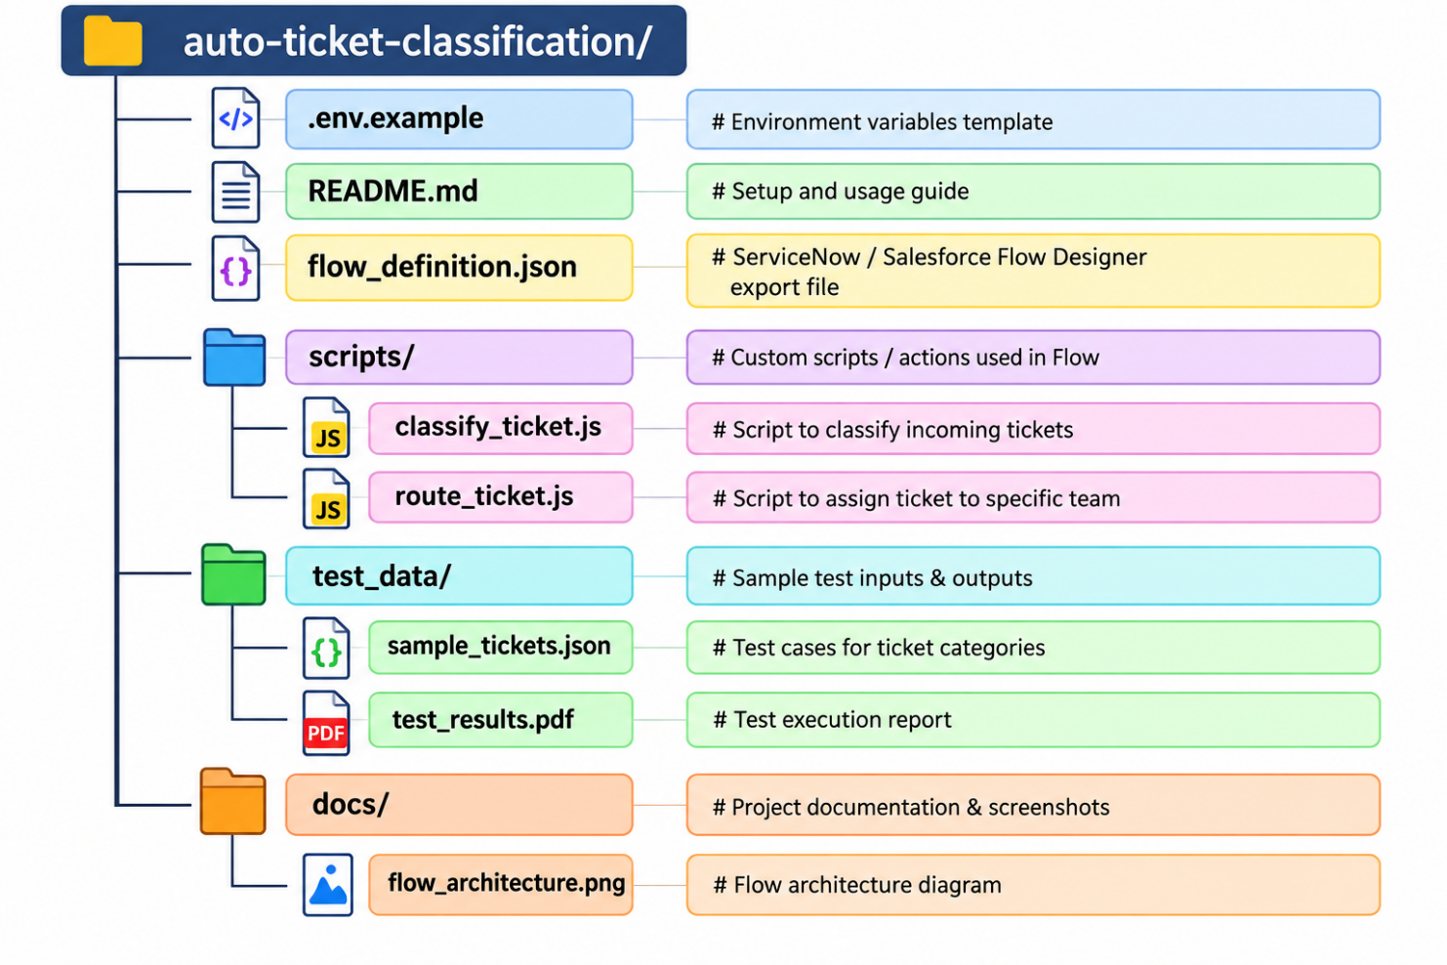

Step 3: Deployment / Access Details

Field | Details
Hosted / Deployed URL | https://developer.servicenow.com/dev.do#!/home
Login Credentials  (Demo) | [Provide demo username and password for evaluator access]
Platform / Hosting  Provider | [e.g., Render, Vercel, AWS, Heroku, Azure]
Repository Link | https://gitgub.com/sowntharya/ Auto-Ticket-Classification-using- Flow-Designer
Demo Video Link

Step 4: Run Instructions Prerequisites Setup:
- Log in to the ServiceNow Developer Instance (or target platform).
- Ensure Flow Designer permissions (admin or flow_operator role) are granted.
Importing the Flow:
- Navigate to Flow Designer in the platform navigation menu.
- Click on Import and select the flow_definition.json file from the project root directory.
- Click Save and then Publish the flow.
Environment Configuration:
- Import the system properties or update environment keys using the provided .example values.
Executing and Testing the Flow:
- Navigate to Incidents / Tickets -> Create New.
- Fill in the ticket description (e.g., "Database connection timed out" or "Password reset required").
- Submit the ticket and observe automatic field assignment (Category, Subcategory, and Assignment Group) triggered by the Flow Designer.
:

Step 5: Known Issues / Limitations

S.No | Known Issue / Limitation | Workaround / Status
1 | Ambiguous or very short ticket descriptions may be routed to the 'General Support' queue. | Workaround: Added a default fallback rule to assign unclassified tickets to Tier-1 Support for manual review.
2 | Flow execution delay of 2-3 seconds during peak platform API usage. | Status: Asynchronous processing enabled in Flow settings to prevent UI lag.
3 | Multi-language ticket inputs are currently not fully supported. | Status: Future enhancement planned using extended NLP integration.

